Drexel University
College of Engineering
Division of Management and Technology
Department of Engineering Technology
Green Energy
Lab 1 Effect of heat on solar panels

Objectives:
1. Become familiar with the DL Green Kit and solar panel module.
2. Better understand the effect of heat on a solar panel
3. Monitor the effect of wind on a solar panel.

Introduction:
Solar panels can be installed in many different configurations and locations. One factor that is important to take into account, regardless of the panels surrounding climate, is radiant heat. Radian heat can greatly affect the performance of the performance of a solar panel. The nature of the solar panel is affected by radiant heat and will not be able to produce as much voltage and current. Too much radiant heat can also damage a solar panel, shortening its lifespan.

Procedure:
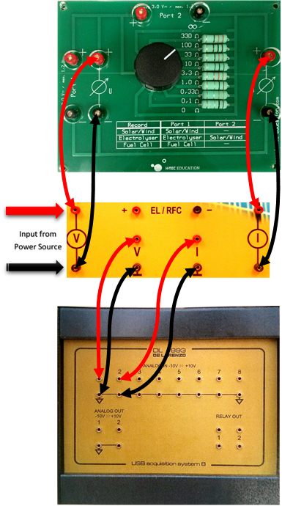
Connect the Data acquisition board (DAQ) to the multi-decade resistor as shown. Connect the solar panels to the input socket. Turn on the computer and select the program DL Greenkit. Once the program is running, we can see the connect icon at the lower left-hand side of the screen that shows the connection to the DAQ Board. Connect DAQ Board to the computer via USB cable. The icon should illuminate green once the connection has been successfully established. Acquire the light source and place it on the table so that it can be positioned to point directly at the solar panels. Connect a power cable to the light and insure that it functions correctly.
Acquire a fan and place it in a position on the table so that it aims at the panel and will be able to cool it. Plug in the fan and insure that it is functioning properly. Select the 33 ohm position on the dial of the Multi-decade Resistor.
Begin the experiment by clicking the trash can icon in DL Greenkit software to clear the readings. Shortly after, turn on the solar panel test bench’s light and click the screen capture icon to record the voltage and current readings when the solar panel is cool. Allow the solar panel to heat up for the next 10 minutes. Take a screen shot to record the voltage and current each minute while the panel is heating up. After 10 minutes has passed or voltage and current of the panel is stable, turn on the fan and insure it is cooling the panel. Repeat the process while the panel is cooling and record the voltage and current by taking a screen shot every minute.

Time(min)  Heating | Temperature | Voltage (V) | Current (A) | Time(min)  Cooling | Temperature | Voltage (V) | Current (A)
0 |  |  |  | 11
1 |  |  |  | 12
2 |  |  |  | 13
3 |  |  |  | 14
4 |  |  |  | 15
5 |  |  |  | 16
6 |  |  |  | 17
7 |  |  |  | 18
8 |  |  |  | 19
9 |  |  |  | 20
10

Table 1.1
Analysis:
- Use the data gathered from this experiment to make two separate plots for both the voltage and currents as functions of time.
- Explain any trends and the behaviour of the plots
- If you were to mount solar panels on a house, would you rather mount them directly to the roof or mount them so a gap is present between the panels and the roof. Explain why.
- In which climate would a solar panel perform better in, Maine or Florida? Explain why.

