Drexel University
College of Engineering
Division of Management and Technology
Department of Engineering Technology Green Energy
Lab 2 Effect of Tilt Angle on solar panels

Objectives:
- Become familiar with the DL Green Kit and solar panel module.
- Better understand the effect of Tilt Angle on a solar panel.
- Better understand the effect geographical location of the solar panel installation.

Introduction:
Solar panels can be installed in many different configurations and locations. One factor that is important to take into account, regardless of the panels surrounding climate, is the tilt angle of the solar panel’s installation with respect to the sun. Fundamentally, the best angle is the one that points directly in line with the light source. Most of the time, this is not possible. Since the sun appears to be moving in the sky during the day, a solar panel can only gather a portion of the light depending on its fixed tilt angle. So there is a compromise to make here; what angle is best for the given solar panel application?

Procedure:
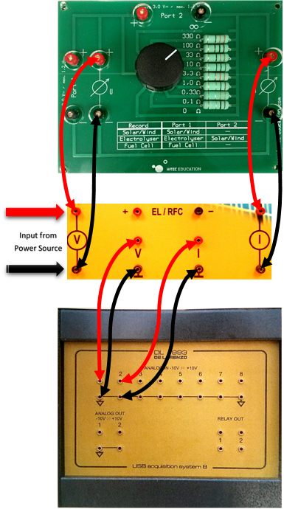
Connect the Data acquisition board (DAQ) to the multi-decade resistor as shown. Connect the solar panels to the input socket. Turn on the computer and select the program DL Greenkit. Once the program is running, we can see the connect icon at the lower left-hand side of the screen that shows the connection to the DAQ Board. Connect DAQ Board to the computer via USB cable. The icon should illuminate green once the connection has been successfully established. Acquire the light source and place it on the table so that it can be positioned to point directly at the solar panels. Connect a power cable to the light and insure that it functions correctly.
Acquire a fan and place it in a position on the table so that it aims at the panel and will be able to cool it. Plug in the fan and insure that it is functioning properly. Select the 33 ohm position on the dial of the Multidecade Resistor.
Begin the experiment by clicking the Trash can icon in DL Greenkit software to clear the readings. Shortly after, turn on the solar panel test bench’s light and click the screen capture icon to record the voltage and current readings when the solar panel is cool. Move the light source to the left of the center of the solar panel and click the Screen Capture icon to record the voltage, current and power. Do this in multiple stages and record the electrical data at each angle. Move the light source to the right of the center of the solar panel and click the Screen Capture icon to record the voltage, current and power. Do this in multiple stages and record the electrical data at each angle. Switch off the light source and disconnect the DAQ

Angle (degrees) | Voltage (V) (Volts) | Current (I) (Amps) | Power  (P) = V*I  (Watts)
60
45
30
15
0
-15
-30
-45
-60

Table 2.1 Analysis:
- Use the data gathered from this experiment to make separate plots for both the voltage, current and power as functions of time.
- Explain any trends and the behavior of the plots
- If you were to mount solar panels on school property, what “fixed” tilt angle would be best suited for getting most power from the sun? Explain why.
- In which geographical location would the solar panel’s flat surface point straight up at the sun?
Explain why.

