Drexel University
College of Engineering
Division of Management and Technology
Department of Engineering Technology
Green Energy
Lab 1 Effect of Shade on solar panels

Objectives:
1. Become familiar with the DL Green Kit and solar panel module.
2. Better understand the effect of shade on solar panel.
3. Understand the importance of internal protection for solar panels.
4. Understand factors to be considered during placement of a solar panel.

Introduction:
Solar panels can be installed in many different configurations and locations. An important factor to take into account is the shade and overcast. Shade is major factor involved in reducing the efficiency of a solar panel. A small part of the panel covered in shade causes a large decrease in power output and can even cause physical damage to solar panel. The physical damage can be avoided by using internal protection. This can be done by using diodes.

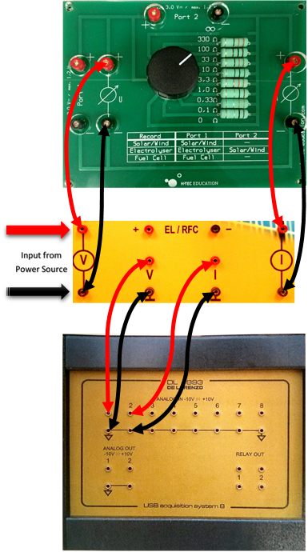
Procedure:
The solar panels will be connected in series for this experiment. Connect the Data acquisition board (DAQ) to the multi-decade resistor as shown. Now connect the negative terminal of the top solar panel to the negative terminal of the bottom solar panel. Connect the solar panels to the input socket. Turn on the computer and select the program DL Greenkit. Once the program is running, we can see the connect icon at the lower left-hand side of the screen that shows the connection to the DAQ Board. Connect DAQ Board to the computer via USB cable. The icon should illuminate green once the connection has been successfully established. Acquire the light source and place it on the table so that it can be positioned to point directly at the solar panels. Connect a power cable to the light and insure that it functions correctly.
Acquire a fan and place it in a position on the table so that it aims at the panel and will be able to cool it. Plug in the fan and insure that it is functioning properly. Select the 33 ohm position on the dial of the Multidecade Resistor.
Begin the experiment by clicking the trash can icon in DL Greenkit software to clear the readings. Shortly after, turn on the solar panel test bench’s light and click the screen capture icon to record the voltage and current readings when the solar panel at this point. Next, place a sheet of face tissue over the entire surface of both the solar panels. This is to simulate overcast. Click the Screen Capture icon to take a snapshot of the voltage, current and power at this point.
Now, remove the facial tissue and replace with a regular opaque sheet of paper and cover (1/2) of one of the two solar panels (ex: lower solar panel). Click the Screen Capture icon to take the snapshot of the voltage, current and Power. Now shade one of the two panels (ex: lower solar panel) entirely with the opaque sheet of paper. Click the Screen Capture icon to record the voltage, current, power. The opaque sheet of paper will simulate a shadow cast by a tree or a man-made object (ex: a high rise building).

Shade type | Voltage (V) (Volts) | Current (I) (Amps) | Power (P) = V*I (Watts)
No shade |  |  | P₁=
Overcast (Facial Tissue) |  |  | P₂=
½ of one panel (Opaque paper) |  |  | P₃=
Complete panel (Opaque Paper) |  |  | P₄=
Table 3.1
Analysis:
- Analyze the results in terms of efficiency ratings for each step.
Facial Tissue (Over cast simulation)
% Power Loss = $\frac{P2}{P1}*100=$
Shade ½ of the lower (or) upper solar panel
% Power Loss = $\frac{P3}{P1}*100=$
Shade all of the lower (or) upper solar panel
% Power Loss = $\frac{P4}{P1}*100=$
- When charging a battery with a solar panel a diode protects the solar panel from draining a battery when sun is not shining. It only allows current to flow in one direction from the solar panel into the battery and it blocks the current flow in the opposite direction. A diode can also protect the solar panel from the effect of shading. Find out how this is accomplished.

