Drexel University
College of Engineering
Division of Management and Technology
Department of Engineering Technology
Green Energy
Lab 4 Maximum Power Point (MPP) of Solar panel

Objectives:
1. Become familiar with the DL Green Kit and solar panel module.
2. To understand Maximum Power Point (MPP) and its definition
3. To understand the effect of Load resistance on a solar panel.

Introduction:
Solar panels have a Maximum Power Point (MPP). MPP is not just Maximum Voltage or Maximum Current by itself but it is the Maximum Power that is produced when voltage and current are multiplied. The resistance of the solar panel should match the load resistance in order to produce the maximum power.

Procedure:
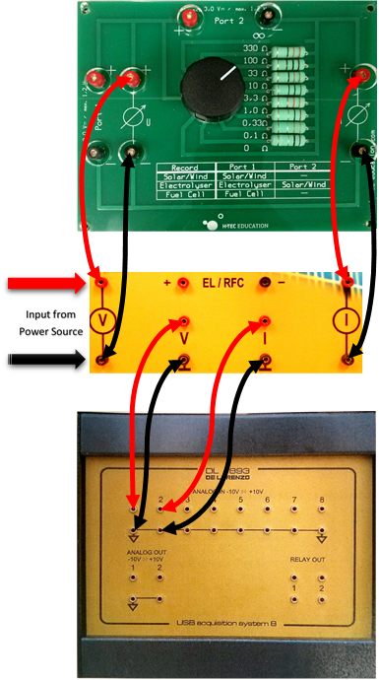
Connect the Data acquisition board (DAQ) to the multi-decade resistor as shown. Connect the solar panels to the input socket. Turn on the computer and select the program DL Greenkit. Once the program is running, we can see the connect icon at the lower left-hand side of the screen that shows the connection to the DAQ Board. Connect DAQ Board to the computer via USB cable. The icon should illuminate green once the connection has been successfully established. Acquire the light source and place it on the table so that it can be positioned to point directly at the solar panels. Connect a power cable to the light and insure that it functions correctly.
Acquire a fan and place it in a position on the table so that it aims at the panel and will be able to cool it. Plug in the fan and insure that it is functioning properly

Note: Perform the following steps in a rapid fashion in order to avoid over heating of the solar panels.

Select the multi-decade resistor to open circuit (R=infinity) ohms. Begin the experiment by clicking the trash can icon in DL Greenkit House software to clear the readings. Shortly after, turn on the solar panel test bench’s light, wait for about 5 seconds and click the screen capture icon to record the voltage and current readings. Switch to 330ohms and wait about 5 seconds, then click the Screen Capture icon to take a snapshot of the voltage, current and power. In succession, switch to 100, 33, 10,
3.3, 1, 0.33 and 0.1 ohms and click the Screen Capture icon to take a snapshot of the voltage, current and power. Allow about 5 seconds between switching the resistance values.
Next, to understand the effect of shift in light on the MPP, move the light one side (left or right) and repeat above process starting with R=infinity ohms, 330, 100, 33 and so on. Switch off light source and the “Power1” and “Load1” switches.

Observations with straight light source
Load  Resistance  (ohms) | Voltage (V) (Volts) | Current(I) (Amps) | Power  (P) = V*I  (watts)
Infinity
330
100
33
10
3.3
1
0.33
0.1

Table 4.1

Observation with shifted light source
Load  Resistance  (ohms) | Voltage (V) (Volts) | Current(I) (Amps) | Power  (P) = V*I  (watts)
Infinity
330
100
33
10
3.3
1
0.33
0.1
Table 4.2
Analysis:
- Use the data gathered from this experiment to make two separate plots for both the tables: a. Voltage vs. Current
b. Voltage vs. Power
- Explain the difference between MPP observed when light source is straight and MPP when light source is shifted to a side.

