

Introduction to Bioinformatics
Drexel University & CAPA High School
NSF DK-12 Program

Objective:
The goal of this lab is to introduce you to the field of bioinformatics and demonstrate some of the applications commonly used. We will touch upon three main components of the field; biology, computer science and statistics. After completing this lab you will be able to describe to someone else what the study of bioinformatics is, why it’s important, who is using it, and where to go to find more information.

Introduction:
Bioinformatics is a field that emerged due to a need to understand biology at the molecular level. Most of us have heard the term DNA before and know that it contains all of the information to build a living organism. Scientists are interested in understanding DNA because they can use the information to have a deeper understanding of how living things work. For example, if we know how a disease works on the molecular level we can work to develop a cure for the disease that targets just the disease with no side effects. The medication will be designed to target only the disease and nothing else. This has been very difficult in the past which is why so many medications have side effects. DNA contains so much information that we require special tools to sift through the data and extract meaningful information. Bioinformatics begins to address this issue through the development of these special tools.

The tools described above are derived from other fields of study, namely statistics and computer science. Statistics is a branch of mathematics that involves collecting, analyzing, explaining and presenting data. Sometimes very complex algorithms are developed to condense the large amount of information contained in a sample of DNA. The algorithms are implemented using computer programs developed by computer scientists. These are generally the same type of people that develop software for your computer. It is more common now to see a person in bioinformatics that is competent in all three areas. This person is known as a bioinformatician.

Since bioinformatics is centered on biology it is a good idea to go over some basic molecular biological concepts. Genomics is primarily the area we are concerned with and will be focusing on. This will provided a deeper appreciation for how living organisms work and what we can do with an understanding of them.

Background:
We know from basic biology that cells are the basic building blocks of life. Every instruction that the cell needs to perform is contained in its DNA. Every organism on our planet is made up of the same chemical and physical components. What varies from organism to organism is the sequence of its DNA. A DNA sequence is a side-by-side arrangement of bases along the strand of DNA. These bases are known as nucleotides. The exact order of the sequence describes the instructions required to create that particular organism. Furthermore, each organism has its own unique traits. For example, we are all humans in the room, but not all of us have exactly the same DNA. Some of us have blond hair while others have brown or black. Each one of those traits is reflected slightly differently in our DNA. No two people are exactly alike.

The genome is the complete set of an organism’s DNA. Genomes vary widely in size. The fruit fly has a genome that is approximately 137 million base-pairs in length. This is small compared to the human genome which contains about 3.2 billion. Depending on the organism generally every cell contains the entire genome. Except for red blood cells every cell in your body contains your complete genome; all of the instructions needed for you to function.

Your complete genome is contained in a set of 46 chromosomes arranged in 23 pairs. Your entire DNA is broken up and stored in these chromosomes. Each sequence of DNA in each chromosome contains many genes. These are the basic physical and functional units of heredity (e.g. green or blue eyes, etc.) There are about 25,000 genes in the human body. Scientists currently understand less than half of our genes. Furthermore, genes make up only about 2% of our DNA. There is much that we still need to learn about our genome.

Genes are important because they contain the instructions for making proteins. Proteins are what the cell uses to carry out its functions. Proteins may work separately or together and are constantly being produced. The amount of any one protein in the body may change from one moment to the next and are subject not only to the instructions contained in the DNA and genes, but also by the environment. For example, we eat and digest our food so that cells in our body get the required nutrients (e.g. proteins) we require to function.

Figure 1: Expanded view of a cell’s genome

Figure 1 above shows an expanded view of our genome based on the discussion we had above. To review our discussion:
- Every cell contains our genome
- Our genome is made up of 46 chromosomes each containing a different sequence of our DNA
- Each strand of DNA contains base-pairs of nucleotides
- Different nucleotide sequences of varying length describe each of our genes
- Our genes contain the instructions for making proteins
- Cells use the proteins to function

With this understanding we can now investigate some tools that have been developed by bioinformaticians to sift through the massive amounts of information contained in our DNA, genes and proteins. Our lab will focus on forensics and how we can use the information extracted from a genetic sample to identify where the genetic material originated from.
Lab 1: The Governor has been poisoned!!

The scene:
The governor was just rushed into the emergency room at the hospital where you work. Doctors determined that he has been poisoned by some unknown substance and is in critical condition. The police found him in his office with a white colored beverage spilled on the floor. Thinking that the beverage may be linked to the poisoning they brought the drink to the hospital with them.

The problem:
While the governor lays in critical condition a sample of the beverage was sent to the lab. Some common molecules such as sugar were found, but there were several unidentified proteins. The lab has asked you to help figure out what are these unidentified proteins. They need your results fast so that they can give the governor an antidote to the poison. His life is now in your hands.

Questions you need to answer:
For each of the unidentified proteins you need to answer:
- What is the unknown protein?
- Where did it come from?
- What is its function?
- Could one of the proteins be responsible for the poisoning?
- What other features does the protein have?

How to solve the problem:
We recall from biology that proteins are sequences of amino acids. These amino acids are coded from the genes from the DNA. You have been given a file containing the amino acid sequence for each protein. We are going to use a program called BLAST to analyze this sequence.
BLAST compares the sequence you input to all of the other protein sequences currently known to science. This information is contained in a SwissProt database. This database is maintained by scientists and is constantly being updated.

Activity:
- Go online to access the SwissProt database using the BLAST algorithm
http://mrs.cmbi.ru.nl/mrs-3/
- Click on BLAST on the left hand side
- Copy and paste the protein sequence for the first unidentified protein
The protein sequences can be found at the end of this lab in appendix A

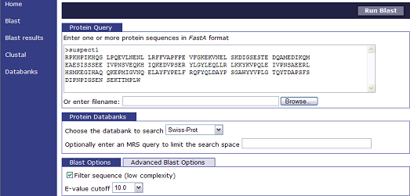
Figure 2: BLAST interface for protein sequences
- Under Protein Databanks make sure the Swiss-Prot databank has been selected
- Click Run Blast in the upper right hand corner to search the database
- Once the program has finished its search it will display the results

The search result for unidentified protein 1 provides numerous matches. This means that all of these proteins have similar sequences and that unidentified protein 1 could be one of them. The search results are ranked so that the one on the upper part of the list is closer matched to unidentified protein 1 than ones lower on the list. The e-value is an indicator of the similarity between your input sequence and the results of the search. A smaller e-value means a closer match.

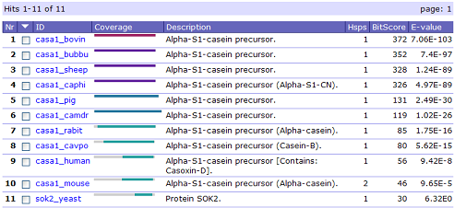
Figure 3: Ranked BLAST search results

Since the database reports the results in ranked order we should start with the first one. Click on the name of the protein to view it in detail.

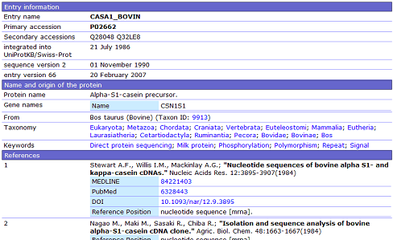
Figure 4: Detailed description of Nr 1

Using this information we can answer the five questions for unidentified protein 1. We still need to do a search for each of the other three unidentified proteins though. Work together in small groups to research the rest of the proteins. Find out what the beverage most likely was and how the governor was poisoned. Remember he is laying in critical condition so you must act quickly!

Lab 2: Two suspects have been caught!!
Who poisoned the Governor?

The Scene:
Now that the governor is back on his way to recovery the lab has been asked to assist in identifying the person who poisoned the governor. The police have two suspects in custody and a hair sample from the crime scene. Hair samples have been taken from the two suspects and have been sent to the lab along with the crime scene hair sample. The lab has extracted DNA from each sample and has asked you to compare their sequences to see if there is a match between a suspect and the crime scene.

The Problem:
We recall from our discussion before that the human genome is approximately 3.2 billion base-pairs in length. It costs a great deal of money and time to sequence a complete genome so comparing the genomes of each of the suspects is unreasonable. Furthermore, each person’s genome is 99.9% identical so it would be very difficult to find any differences. Instead we are going to look at 13 different places in the genome that have been determined by scientists to show the differences between each human being. While it is not 100% accurate it substantially helps identify the criminal along with other evidence.

Questions you need to answer:
- Which suspect has the closest DNA match to the crime scene sample?
- Is there a reasonable doubt that this person didn’t poison the governor?

How to solve the problem:
We are going to use the BLAST algorithm again to compare two DNA nucleotide sequences. This time though we’re going to use a different interface for the algorithm. Remember that bioinformatics is an interdisciplinary field; biology, computer science and mathematics. The mathematical algorithm used in the first lab is the same one being used here. However, a different group of computer scientists developed the program we are now about to use. Bioinformaticians have the freedom to develop the tools they feel will work best for them.

Activity:
- Go online and access the BLAST page from NCBI (National Center for Biotechnology Information)
http://blast.ncbi.nlm.nih.gov/Blast.cgi
- Under Basic BLAST click nucleotide blast. This tool is used to compare two nucleotide sequences.
- In the middle of the page make sure you check the box for “Blast 2 sequences”
- Enter the crime scene nucleotide sequence in the top box
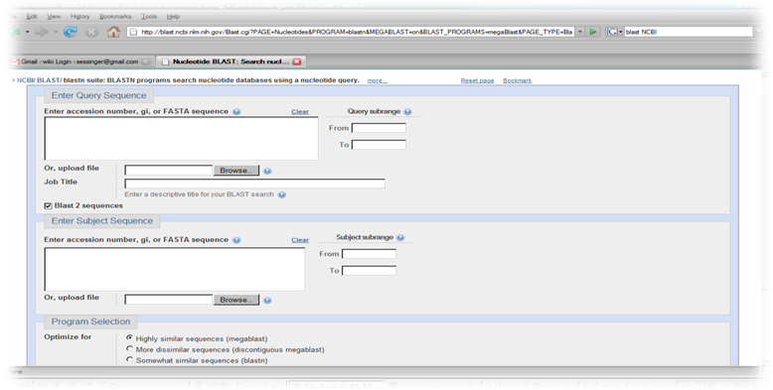
Figure 5: BLAST nucleotide sequence comparison screenshot

- Put the nucleotide sequence for suspect 1 in the box below it. You can find the nucleotide sequences in appendix B at the end of this lab
- Select “Somewhat similar sequences” under the Program Selection
- Click on BLAST on the lower left hand of the screen to run the analysis
- The result of the analysis is provided on the next screen. You may have to wait a few moments.
- You will want to focus on the percentage of identities. The higher the percentage the closer the sequences are aligned.
- Repeat the process for the second suspect and then compare your results.

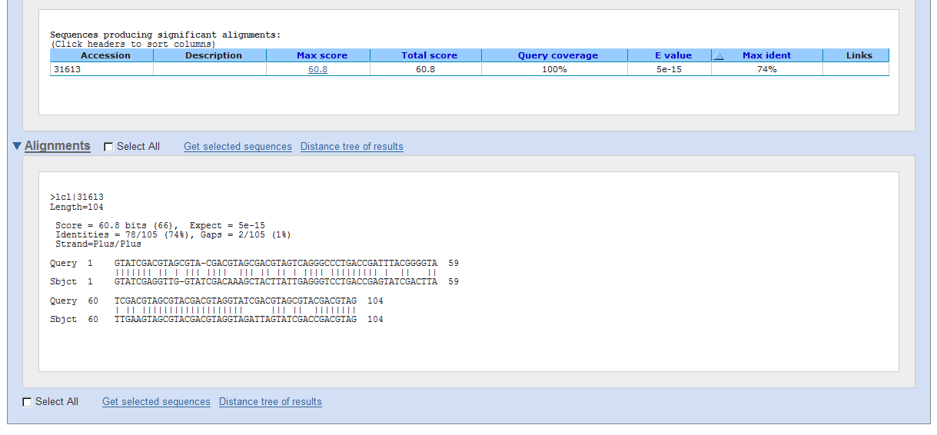
Figure 6: Result of nucleotide sequence comparison

Further Exploration:
DNA Forensics - http://www.ornl.gov/sci/techresources/Human_Genome/elsi/forensics.shtml
Several areas of DNA forensics are explained at this website:
- How does forensic identification work?
- Is DNA an effective identifier?
- How is DNA typing done?
- What are some of the DNA technologies used in forensic investigations?
- Some Interesting Uses of DNA Forensic Identification

References:
1. Explaining Genomics and Bioinformatics to High School Students
2. Human Genome Project Primer
3. http://www.bioinformaticsatschool.eu/
4. DNA Forensics http://www.ornl.gov/sci/techresources/Human_Genome/elsi/forensics.shtml
5. NCBI BLAST http://blast.ncbi.nlm.nih.gov/Blast.cgi

Appendix A
Protein Sequences:
>unidentified protein1
RPKHPIKHQG LPQEVLNENL LRFFVAPFPE VFGKEKVNEL SKDIGSESTE DQAMEDIKQM
EAESISSSEE IVPNSVEQKH IQKEDVPSER YLGYLEQLLR LKKYKVPQLE IVPNSAEERL
HSMKEGIHAQ QKEPMIGVNQ ELAYFYPELF RQFYQLDAYP SGAWYYVPLG TQYTDAPSFS
DIPNPIGSEN SEKTTMPLW
>unidentified protein2
QYSSNTQQGR TSIVHLFEWR WVDIALECER YLAPKGFGGV QVSPPNENVA IHNPFRPWWE
RYQPVSYKLC TRSGNEDEFR NMVTRCNNVG VRIYVDAVIN HMCGNAVSAG TSSTCGSYFN
PGSRDFPAVP YSGWDFNDGK CKTGSGDIEN YNDATQVRDC RLSGLLDLAL GKDYVRSKIA
EYMNHLIDIG VAGFRIDASK HMWPGDIKAI LDKLHNLNSN WFPEGSKPFI YQEVIDLGGE
PIKSSDYFGN GRVTEFKYGA KLGTVIRKWN GEKMSYLKNW GEGWGFMPSD RALVFVDNHD
NQRGHGAGGA SILTFWDARL YKMAVGFMLA HPYGFTRVMS SYRWPRYFEN GKDVNDWVGP
PNDNGVTKEV TINPDTTCGN DWVCEHRWRQ IRNMVNFRNV VDGQPFTNWY DNGSNQVAFG
RGNRGFIVFN NDDWTFSLTL QTGLPAGTYC DVISGDKING NCTGIKIYVS DDGKAHFSIS
NSAEDPFIAI HAESKL
>unidentified protein3
QQNLPQRYIE LVVVADHRVF MKYNSDLNTI RTRVHEIVNF INGFYRSLNI HVSLTDLEIW
SNEDQINIQS ASSDTLNAFA EWRETDLLNR KSHDNAQLLT AIELDEETLG LAPLGTMCDP
KLSIGIVQDH SPINLLMGVT MAHELGHNLG MEHDGKDCLR GASLCIMRPG LTKGRSYEFS
DDSMHYYERF LKQYKPQCIL NKP
>unidentified protein4
LIVTQTMKGL DIQKVAGTWY SLAMAASDIS LLDAQSAPLR VYVEELKPTP EGDLEILLQK
WENGECAQKK IIAEKTKIPA VFKIDALNEN KVLVLDTDYK KYLLFCMENS AEPEQSLACQ
CLVRTPEVDD EALEKFDKAL KALPMHIRLS FNPTQLEEQC HI
Appendix B
13 loci DNA Samples:

>Crime scene
GTATCGAC GTAGCGTA CGACGTAG CGACGTAG TCAGGGCC CTGACCGA TTTACGGG GTATCGAC GTAGCGTA CGACGTAG GTATCGAC GTAGCGTA CGACGTAG

>Suspect1
GTATCGAG GTTGGTAT CGACAAAG CTACTTAT TGAGGGTC CTGACCGA GTATCGAC TTATTGAA GTAGCGTA CGACGTAG GTAGATTA GTATCGAC CGACGTAG

>Suspect2
GTATCGAC GTAGGTAT CGACGTAG CGACGTAT TCAGGGCC CTGACCGA GCTACTGG GTATCGAC GTAGCGTA CGACGTAG GTATCGAC GTAGCGTA CGACGTAG

