In an image, “contrast” is the measure of the difference in brightness between the light and dark areas of an image. In many cases, adjusting the contrast in an image can improve the quality of an image. In certain situations, such as medical imaging like identifying potential cancerous growths in x-rays of human tissue, contrast can be essential. In medical imaging, doctors and researchers want to identify sections of an image that have particular characteristics (color, density, etc.) that are more likely to contain cancerous or other potentially dangerous growths. As a result, clearly depicting these sections, which often involves increasing the contrast and making the light lighter and/or the dark darker, is essential in medical imaging. For example, consider the images in Figure 1. The regions identified with arrows are potentially cancerous growths and technology can assist doctors by increasing the contrast on these particular regions in order for a more thorough visual inspection.

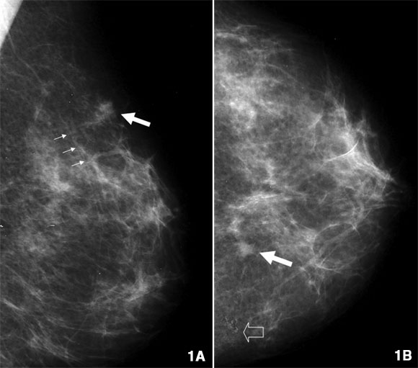

Figure 1: Potentially dangerous regions identified on a mammogram

Increasing contrast can be achieved by manipulating the intensity of the individual pixels in a digital image. In the following activities, we will explore three potential ways to increase image contrast, each of which involve applying transformations to the intensity of each pixel in the image.

#### Activity 1: Increasing Image Contrast by Hand

### **I. Linear Transformation.** One potential way to increase the contrast in a digital image is to apply a linear transformation to the image matrix (ie. multiplying each value in by a specific number). The following procedure can be used to apply a linear transformation on a given image.

1. Select the value for your linear transformation (in this case we will be multiplying each value by 2, but you can use any number)
2. For every cell in the matrix, multiply the values in each cell by 2
3. *Now try it out.* Consider the portion of a digital image shown below in Figure 2. Follow the procedure outlined above to preform the linear transformation “multiply by two.” Place your answers in the Blank Matrix in Figure 3.

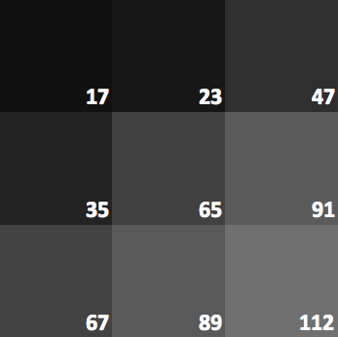

Figure 2: Portion of a Digital Image

|  |  |  |
| --- | --- | --- |
|  |  |  |
|  |  |  |
|  |  |  |
|  |  |  |

Figure 3: Blank Matrix for Linear Transformation

1. Download the Excel document from <http://dk12.ece.drexel.edu/MT/transform.xlsx> and replace the original values with your calculated values. The Excel spreadsheet automatically re-calculates the color of the cell to match your entry. What do you notice? How is the image different? Do you think the transformation increased the contrast in the image? Why or why not? *(Remember, contrast is the difference between light and dark in the image)?*

### **II. Quadratic Transformation.** Another transformation that may be useful is a quadratic transformation, (ie. squaring each value). Consider the portion of a digital image shown above in Figure 2. Square each value and record your answers in the Blank Matrix in Figure 4.

|  |  |  |
| --- | --- | --- |
|  |  |  |
|  |  |  |
|  |  |  |

Figure 4: Blank Matrix for Quadratic Transformation

1. Return to the Excel document from that you downloaded above and replace the original values with your calculated values. The Excel spreadsheet automatically re-calculates the color of the cell to match your entry. What do you notice?
2. How is the quadratic image different from the original (non transformed) image? Do you think the transformation with normalization increased the contrast in the image? Why or why not? *(Remember, contrast is the difference between light and dark in the image)?*

The resulting matrix should look something like Figure 5. Even though the values appear to be *much* higher in the lower right corner than the upper left corner, each of the cells appear to be the same intensity. Why might that be?

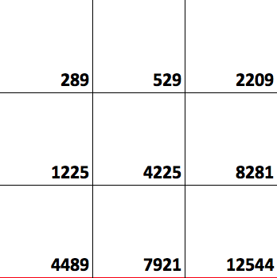

Figure 5: Matrix after Quadratic Transformation

As was mentioned above, the great variation in the intensity is not displayed because “full saturation” of light is represented by 255 and, since there is nothing greater than full saturation” every number above 255 is still represented by white. But this does not capture the significant differences in the intensities. In order to make these differences apparent, we “normalize” the image, which is an additional step that can be used to take into account instances where many of the resulting intensity values are higher than 255. In order to normalize the image, a new unit is created that is 1/255 as large as the highest value and then the value of each pixel is calculated in terms of that unit. Below is a procedure that can be used to normalize an image.

1. Identify the maximum value in the matrix.
2. Divide the maximum value by 255. *Think about it this way. Normally, we have a range of intensities that can vary between 0 and 255 and each integer represents one of the 255 increments (steps) between 0 and 255. But in this case, we have a range of intensities that can vary between 0 and the maximum value. We still want 255 “steps” between 0 and dividing the maximum value by 255 produces the appropriate increment for each step.*
3. Take the intensity in each cell and divide it by the unit (the increment) calculated in #4.
4. *Now try it out.* Consider the portion of a digital image shown above in Figure 4. Use the procedure above to (a) calculate the new unit and (b) complete the normalized matrix in Figure 6.

|  |  |  |
| --- | --- | --- |
|  |  |  |
|  |  |  |
|  |  |  |

Figure 6: Blank Matrix for Normalizing

1. Return to the Excel document from that you downloaded above and replace the original values with your normalized values. The Excel spreadsheet automatically re-calculates the color of the cell to match your entry. How does this new matrix differ from the original quadratic transformation? What else do you notice?
2. How is the normalized image different from the original (non transformed) image? Do you think the transformation with normalization increased the contrast in the image? Why or why not? *(Remember, contrast is the difference between light and dark in the image)?*

#### Activity 2: Transformation Applets

1. Download a quality image of the moon <http://dk12.ece.drexel.edu/MT/moon.jpg>
2. Open the “Transformation” applet at <http://dk12.ece.drexel.edu/image_guis/Transformation.html> or following the link on the main Image Processing Labs page.

The applet is designed perform a variety of transformations on a selected image. For example, the variety of transformations take the value (intensity) of each cell and replaces it with the following function values

* + Square (Quadratic): *f* (*x*) = *x*2
  + Square Root: *f* (*x*) =



* + Exponential: *f* (*x*) = *ex*
  + Linear: *f* (*x*) = 2*x*
  + Logarithmic (Natural Log): *f* (*x*) = ln *x*

Additionally, the applet displays both the raw transformed image and the normalized image.

1. Click “Select File” and upload the image of the moon from Step #1.
2. Experiment with the various transformations.
   * Verify that the raw transformed image and the normalized image behave as you expect them to.
   * Convince yourself that the linear and quadratic transformations behave similarly to what you found in Activity 1.
   * Describe the result of each normalized transformation.
3. Questions
   * Which transformations appear to be better at increasing contrast? How do you know? Does the increase in contrast allow you view interesting features on the moon. Learn more about them at the following links:
     + <http://en.wikipedia.org/wiki/Lunar_craters>
     + http://en.wikipedia.org/wiki/Ray_system
   * Do any appear to decrease contrast? Why might that make sense?
   * Think about each of the transformation functions and how the actual transformation might relate to the graphs you studied. For example, with a linear function, say *y* = 2*x*, each value is multiplied by 2. So the overall intensity of the light changes, but universally. There is no relative change in the intensity of two given cells before and after the transformation. What about …
     + the quadratic?
     + the square root?
     + the natural log?

As a starting point, think about the graph of the square root. How is the relationship between *x* and *f*(*x*) different close to zero than it is farther away from zero (say around 4)? Think about the two rectangles below, each of which have a width of approximately 0.2.

